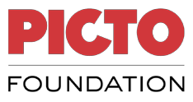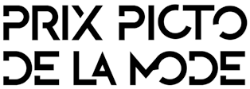
PRIX PICTO DE LA PHOTOGRAPHIE DE MODE 2021
FIRST NAME
LAST NAME
BIRTHDATE
NATIONALITY
COMPLETE ADRESS
TELEPHONE
EMAIL
WEBSITE
AGENT (if you are represented by agent, write his name, email and telephone)
SCHOOL (If yes, which one)
EARN DIPLOMA
NAME OF THE SERIE 1
NAME OF THE SERIE 2

Submissions must be received by September, 10th.
RESPONSABILITY
Picto considers that it has received permission from the participants and winners to use their photographs, to reproduce and distribute in any way whatsoever, by way of poster, on social networks (Facebook, Twitter, Instagram, Linkedin, Pinterest...) or otherwise, one or more of their works with a view to promoting the Prix Picto de la Photographie de Mode. Participants must ensure themselves and guarantee the organisers that the works selected do not infringe the rights of third parties and that they have obtained the necessary authorizations from these third parties for any reproduction or exhibition.

Candidate’s signature preceded by the words « read and approved »
--------------------------------, ----------------------------- (Location) ---------------- (Date)

